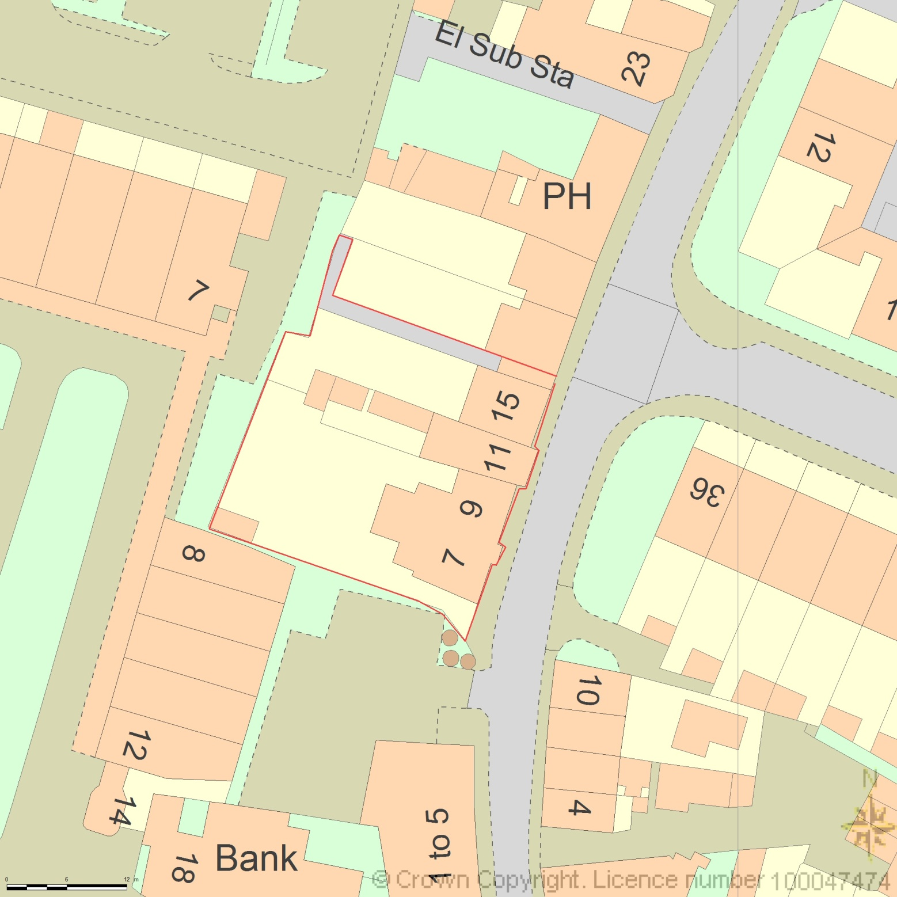
BLOCK PLAN
AREA 90m x 90m
SCALE 1:500 on A4
CENTRE COORDINATES: 523371, 208648

Supplied by Streetwise Maps Ltd
www.streetwise.net
Licence No: 100047474
06/06/2020 11:00:40

