Materials to be used in the construction of the external surfaces of the buildings

Ballroom Wing

Roofing Materials
- Natural roofing slates (matt finish) including all associated lead soakers, flashings hips, valleys etc…
- Plain painted timber fascia

Windows
- Ventrolla Complete New Sash Box Square Top to match existing

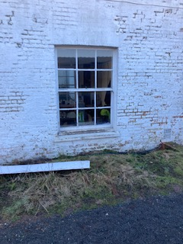

External Doors
- Jeld-wen Longleat four panel

French Doors
- Jeld – Wen Dreamvu

