EXAMPLES OF POTENTIAL EXTERIOR LIGHTING AND ALARM BOXES

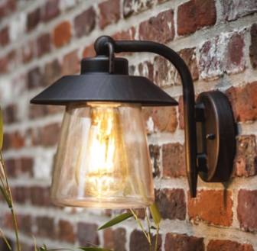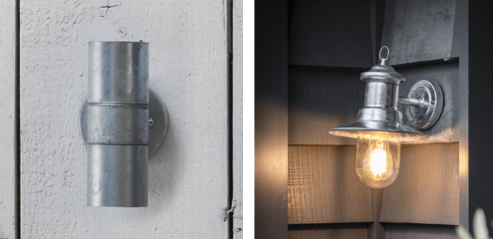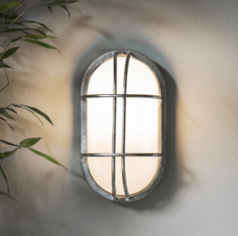

No individual satellite dishes to be attached to any building, communal satellite to be installed in discreet location yet to be decided.